**SQL Server Functions**

Functions in SQL Server are the database objects that contains a set of SQL statements to perform a specific task.

**String Functions**

The string functions are used on char and varchar data types. These functions are used to manipulate the string values in a result set.

1)ASCII -Returns the ASCII value for the specific character

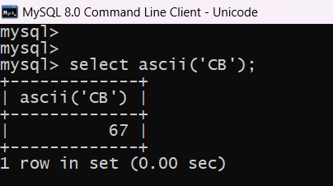

2) CHAR - Returns the character based on the ASCII code

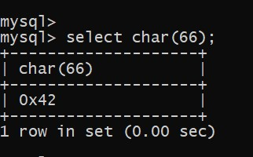

3)LEN - Returns the length of a string

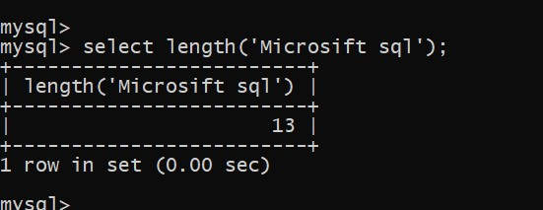

4) LOWER - Converts a string to lower-case

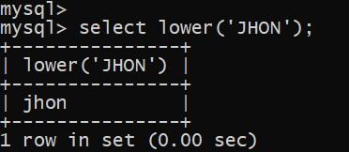

5) REPLACE - Replaces all occurrences of a substring within a string, with a new substring

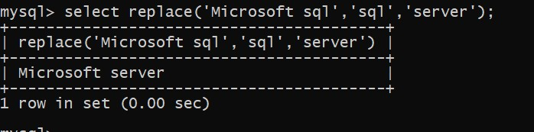

6)REVERSE -Reverses a string and returns the result

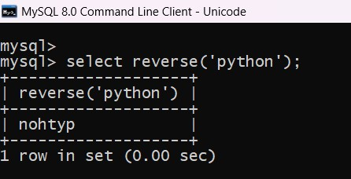

7)UPPER - Converts a string to upper-case

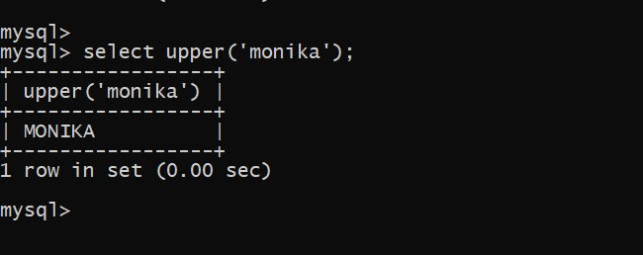

**Mathematical Functions**

The mathematical functions are used to manipulate the numeric values in the result set. Various arithmetic operations can be performed on the numeric values.

1)ABS - Returns the absolute value of a number

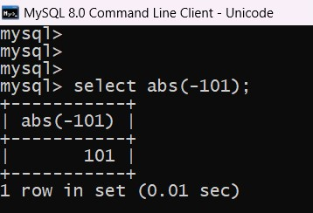

2) SIN - Returns the sine of a number

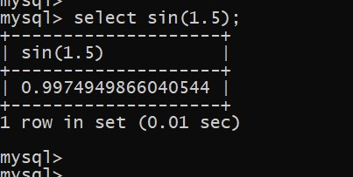

3)CEILING - Returns the smallest integer value that is >= a number

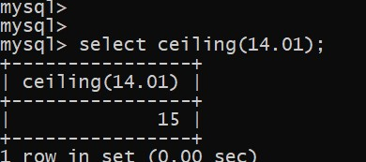

4)EXP - Returns e raised to the power of a specified number

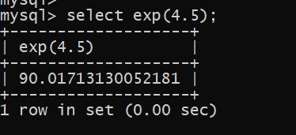

5)FLOOR - Returns the largest integer value that is <= to a number

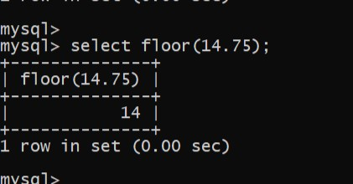

6) LOG - Returns the natural logarithm of a number,

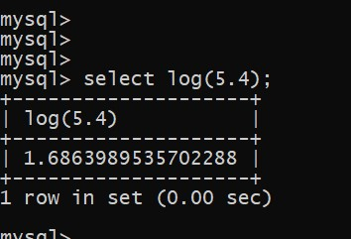

**Using Date Functions**

The date functions can be used to manipulate the date and time values in SQL server. The date values can be parsed during the arithmetic operation.

1)getdate() - Returns the current database system date and time

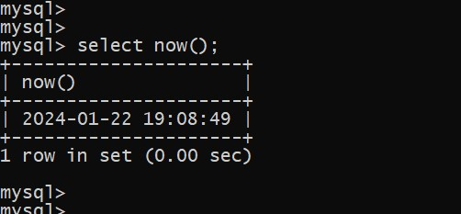

2)DAY - Returns the day of the month for a specified date

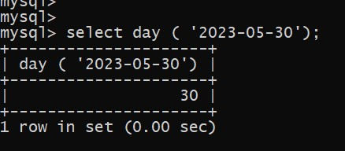

3)MONTH - Returns the month part for a specified date (a number from 1 to 12)

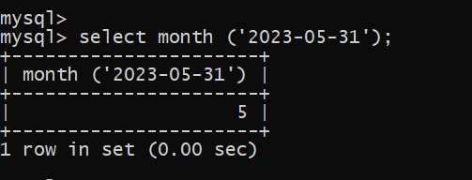

4) YEAR - Returns the year part for a specified date

